МИНИСТЕРСТВО ОБРАЗОВАНИЯ РЕСПУБЛИКИ БЕЛАРУСЬ

УЧРЕЖДЕНИЕ ОБРАЗОВАНИЯ

ГОМЕЛЬСКИЙ ГОСУДАРСТВЕННЫЙ ТЕХНИЧЕСКИЙ

УНИВЕРСИТЕТ ИМЕНИ П. О. СУХОГО

Факультет автоматизированных и информационных систем

Кафедра «Информационные технологии»

ЛАБОРАТОРНАЯ РАБОТА №3

по дисциплине: **«**Программирование сетевых приложений**»**

на тему: «Многопоточное обслуживание клиентов при

организации распределённой обработки информации

средствами стека протоколов *TCP/IP*»

Выполнил: студент гр. ИТП-41

Расшивалов Н.И.

Принял: преподаватель

Гуменников Е. Д.

Гомель 2022

**Цель:** изучить организацию параллельной обработки запросов клиентов с использованием пула потоков.

**Задание:**

Разработать сервер с использованием пула потоков для параллельной обработки запросов клиентов. К серверу подключается много клиентов, все они отправляют задачи (по вариантам), сервер обрабатывает каждый запрос в отдельном потоке (используя пул потоков) и возвращает ответ клиенту.

Задание согласно варианту: *InsertSort*

**Ход работы:**

Результат сортирования представлен на рисунке 1.

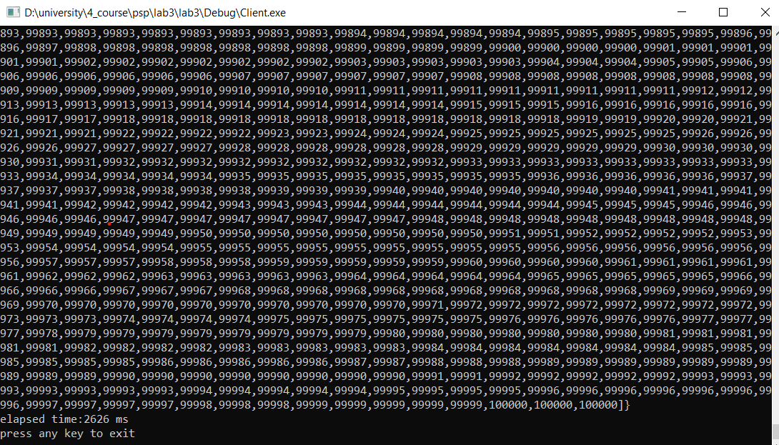

Рисунок 1 – Результат сортирования одного сервера

**Вывод:** в ходе выполнения лабораторной работы получены навыки программирования сокетов, изучен и применен пул потоков для параллельной обработки запросов клиентов.

**ПРИЛОЖЕНИЕ А**

**Листинг программы**

#define UA_ARCHITECTURE_POSIX

#include <iostream>

#include <cstdio>

#include <cstring>

#include <sys/types.h>

#include <sys/socket.h>

#include <netinet/in.h>

#include "rapidjson/document.h"

#include "rapidjson/reader.h"

#include "rapidjson/writer.h"

#include "rapidjson/stringbuffer.h"

#include "rapidjson/memorybuffer.h"

#include <stack>

#include <thread>

#include <boost/thread.hpp>

#include <map>

#include "./common.h"

#include <chrono>

using namespace std;

using namespace rapidjson;

constexpr auto BASE_PORT = 5001;

constexpr auto SERVERADDR = "127.0.0.1";

constexpr auto HEADER_SIZE = sizeof(header);

constexpr auto WORKERS_COUNT = 4;

struct poolItem {

int port;

bool isOpen;

int sock;

bool isEmpty;

};

template <typename T> class ThreadSafeStack {

public:

ThreadSafeStack() {

m_stack = stack<poolItem>();

}

void push(const T& item) {

boost::mutex::scoped_lock lock(m_mutex);

m_stack.push(item);

}

T pop() {

boost::mutex::scoped_lock lock(m_mutex);

if (!m_stack.empty()) {

T item = m_stack.top();

m_stack.pop();

return item;

}

poolItem emptyItem;

emptyItem.isEmpty = true;

return emptyItem;

}

private:

mutable boost::mutex m_mutex;

std::stack<T> m_stack;

};

ThreadSafeStack<poolItem> pool;

template <typename T, typename T2> class ThreadSafeMap {

public:

ThreadSafeMap() {

m_map = {};

}

std::map<T, T2> getAndclear() {

boost::mutex::scoped_lock lock(m_mutex);

std::map<T, T2> mapToReturn;

mapToReturn.insert(m_map.begin(), m_map.end());

m_map = {};

return mapToReturn;

}

void push(T id, T2 value) {

boost::mutex::scoped_lock lock(m_mutex);

m_map[id] = value;

}

std::map<T, T2> getMap() {

return m_map;

}

int size() {

boost::mutex::scoped_lock lock(m_mutex);

return m_map.size();

}

private:

mutable boost::mutex m_mutex;

std::map<T, T2> m_map;

};

ThreadSafeMap<int, double> safe_map;

map<int, double> results_map;

double getResult(map<int, double> results);

void process(int id, poolItem worker, double start, double end, int n);

int receive(int sock, char* buffer, int chunk_size)

{

int offset = 0;

while (chunk_size > 0)

{

int n = recv(sock, buffer + offset, chunk_size, 0);

offset += n;

chunk_size -= n;

}

return offset;

}

double calculateIntegral(double start, double end, double step, int n);

int main() {

for (int i = 0; i < WORKERS_COUNT; i++) {

poolItem item = poolItem();

item.isOpen = false;

item.port = BASE_PORT + i;

pool.push(item);

}

double start;

double end;

int n;

double eps;

/*std::cout << "Input start" << endl;

std::cin >> start;

std::cout << "Input end" << endl;

std::cin >> end;

std::cout << "Input epsilon" << endl;

std::cin >> eps;*/

start = -1;

end = 20;

n = 1;

eps = 0.001;

double step = (end - start) / WORKERS_COUNT;

auto start_time = std::chrono::steady_clock::now();

double previousResult, currentResult;

currentResult = calculateIntegral(start, end, step, n);

double loss;

do {

previousResult = currentResult;

n = 2 * n;

currentResult = calculateIntegral(start, end, step, n);

loss = fabs(previousResult - currentResult);

std::cout << "Current loss " << loss << " Previous:" << previousResult << " Current:" << currentResult << endl;

} while (loss > eps);

auto end_time = std::chrono::steady_clock::now();

auto elapsed_ms = std::chrono::duration_cast<std::chrono::milliseconds>(end_time - start_time);

std::cout << "Total elapsed time:" << elapsed_ms.count() << " ms" << endl;

std::cout << "Square:" << fabs(currentResult) << endl;

for (int i = 0; i < WORKERS_COUNT; i++) {

poolItem item = pool.pop();

if (!item.isEmpty) {

if (item.isOpen) {

header h = header();

h.disconnect = true;

char* header_data = new char[HEADER_SIZE];

h.serialize(header_data);

send(item.sock, header_data, HEADER_SIZE, 0);

close(item.sock);

}

}

}

cout << "press any key to exit" << endl;

int nothing;

cin >> nothing;

return 0;

}

double calculateIntegral(double start, double end, double step, int n) {

auto start_time = std::chrono::steady_clock::now();

int id = 0;

double workerStart;

double workerEnd;

for (int i = 0;i < WORKERS_COUNT;i++) {

bool queued = false;

while (!queued) {

poolItem worker = pool.pop();

if (!worker.isEmpty) {

workerStart = start + step * i;

workerEnd = start + step * (i + 1);

std::thread tA(process, id, worker, workerStart, workerEnd, n);

tA.detach();

queued = true;

id = id + 1;

}

}

}

while (safe_map.size() != WORKERS_COUNT) {

//cout << "Map size" << results_map.size() << endl;

}

auto end_time = std::chrono::steady_clock::now();

auto elapsed_ms = std::chrono::duration_cast<std::chrono::milliseconds>(end_time - start_time);

//std::cout << "Iteration elapsed time:" << elapsed_ms.count() << " ms" << endl;

return getResult(safe_map.getAndclear());

}

void process(int id, poolItem worker, double start, double end, int n)

{

int socket_desc;

socket_desc = socket(AF_INET , SOCK_STREAM , 0);

//cout << "Connecting to server with port " << worker.port << endl;

if (!worker.isOpen) {

worker.sock = socket(AF_INET, SOCK_STREAM, 0);

worker.isOpen = true;

if (worker.sock < 0) {

cout << "Socket error" << endl;

return;

}

sockaddr_in dest_addr;

dest_addr.sin_family = AF_INET;

dest_addr.sin_port = htons(worker.port);

dest_addr.sin_addr.s_addr = htonl(INADDR_LOOPBACK);

if (connect(worker.sock, (struct sockaddr*)&dest_addr, sizeof(dest_addr)) < 0)

{

cout << "Connection Failed" << endl;

return;

}

}

StringBuffer s;

Writer<StringBuffer> writer(s);

writer.StartObject();

writer.Key("start");

writer.Double(start);

writer.Key("end");

writer.Double(end);

writer.Key("n");

writer.Int(n);

writer.EndObject();

header h = header();

h.size = s.GetSize();

//cout << s.GetString() << endl;

char* header_data = new char[HEADER_SIZE];

h.serialize(header_data);

send(worker.sock, header_data, HEADER_SIZE, 0);

if (send(worker.sock, s.GetString(), s.GetSize(), 0) == SO_ERROR) {

cout << "send failed" << endl;

}

char headerBuffer[HEADER_SIZE] = { 0 };

receive(worker.sock, headerBuffer, HEADER_SIZE);

header responseHeader;

responseHeader.deserialize(headerBuffer);

char* buffer = new char[responseHeader.size];

buffer[responseHeader.size] = '\0';

receive(worker.sock, buffer, responseHeader.size);

//cout << "Given response json:" << buffer << endl;

Document d;

d.Parse(buffer);

pool.push(worker);

safe_map.push(id, d["result"].GetDouble());

cout << "finished" << id << endl;

//cout << "added response with id:" << id << endl;

}

double getResult(map<int, double> results)

{

map <int, double> ::iterator it = results.begin();

double result = 0.0;

for (int i = 0; it != results.end(); it++, i++)

{

result = result + it->second;

}

return result;

}

#include <iostream>

#include <cstdio>

#include <cstring>

#include <sys/types.h>

#include <sys/socket.h>

#include <netinet/in.h>

#include "rapidjson/document.h"

#include "rapidjson/reader.h"

#include "rapidjson/writer.h"

#include "rapidjson/stringbuffer.h"

#include "rapidjson/memorybuffer.h"

#include <stack>

#include <thread>

#include "./common.h"

#include <cmath>

using namespace std;

using namespace rapidjson;

constexpr auto BASE_PORT = 5001;

constexpr auto SERVERADDR = "127.0.0.1";

constexpr auto HEADER_SIZE = sizeof(header);

int clientsCount = 0;

int receive(int sock, char* buffer, int chunk_size);

int process(int client_socket);

typedef double(*pointFunc)(double);

double f(double x) {

return pow(x, 3) * cos(x);

}

double integral(pointFunc f, double start, double end, int n) {

double x, step;

double sum = 0.0;

double fx;

step = (end - start) / n;

for (int i = 0; i < n; i++) {

x = start + i * step;

fx = f(x);

sum += fx;

}

return (sum * step);

}

int main()

{

int serverSocket;

if ((serverSocket = socket(AF_INET, SOCK_STREAM, 0)) < 0)

{

cout << "Error socket" << endl;

return 1;

}

int serverNumber = 0;

cout << "Input server number: " << endl;

cin >> serverNumber;

int serverPort = BASE_PORT + serverNumber;

cout << "Will listen on " << serverPort << " port";

sockaddr_in serverAddr;

serverAddr.sin_family = AF_INET;

serverAddr.sin_port = htons(serverPort);

serverAddr.sin_addr.s_addr = htonl(INADDR_LOOPBACK);

if (bind(serverSocket, (sockaddr*)&serverAddr, sizeof(serverAddr)) == SO_ERROR) {

cout << "Bind function failed with error" << endl;

return -1;

}

if (listen(serverSocket, 0) == SO_ERROR) {

cout << "Listen function failed with error" << endl;

return -1;

}

cout << "Waiting for connections..." << endl;

int clientSocket;

sockaddr_in client_addr;

int client_addr_size = sizeof(client_addr);

while ((clientSocket = accept(serverSocket, NULL, NULL))) {

clientsCount++;

//cout << "Connected client" << endl;

std::thread tA(process, clientSocket);

tA.detach();

}

return 0;

}

int process(int lpParam) {

int client_socket;

client_socket = lpParam;

char headerBuffer[HEADER_SIZE] = { 0 };

char header_data[HEADER_SIZE] = { 0 };

header requestHeader;

int bytes_received = 0;

while (true) {

bytes_received = receive(client_socket, headerBuffer, HEADER_SIZE);

requestHeader.deserialize(headerBuffer);

cout << requestHeader.disconnect << endl;

if (requestHeader.disconnect == true) {

cout << "Client disconnected";

break;

}

if (bytes_received == 0) {

continue;

}

char* buffer = new char[requestHeader.size];

buffer[requestHeader.size] = '\0';

receive(client_socket, buffer, requestHeader.size);

cout << "Given json:" << buffer << endl;

Document d;

d.Parse(buffer);

double start = d["start"].GetDouble();

double end = d["end"].GetDouble();

int n = d["n"].GetInt();

StringBuffer s;

Writer<StringBuffer> writer(s);

writer.StartObject();

writer.Key("result");

writer.Double(integral(f, start, end, n));

writer.EndObject();

header responseHeader = header();

responseHeader.size = s.GetSize();

responseHeader.serialize(header_data);

send(client_socket, header_data, HEADER_SIZE, 0);

send(client_socket, s.GetString(), s.GetSize(), 0);

cout << "Sent result:" << s.GetString() << endl;

//delete buffer;

}

clientsCount--;

return 0;

}

int receive(int sock, char* buffer, int chunk_size)

{

int offset = 0;

while (chunk_size > 0)

{

int n = recv(sock, buffer + offset, chunk_size, 0);

offset += n;

chunk_size -= n;

}

return offset;

}

struct header {

bool disconnect;

int size;

void serialize(char* data) {

memcpy(data, this, sizeof(header));

}

void deserialize(char* data) {

memcpy(this, data, sizeof(header));

}

};